Tab 1
Objective Questions

1)What is the total no. of tables present in the data?

1(Data is structured in a single sheet with rows and columns.)

2)What is the total no. of attributes present in the data?

The raw data has 35 Attributes, and after cleaning it, I converted it into 34 Attributes.

3)The data consists of some inconsistent and missing values so ensure that the data used for further analysis is cleaned.

Removed Duplicates
- Checked for duplicate rows using key fields like user, guru, createdAT, and chatstatus.
- Removed redundant records to avoid skewed results during analysis.
- Sometimes the same session can be logged multiple times due to system errors or retries, so comparing user, guru, and timestamp together gives a more reliable check.
- The total rows consists of the raw data is 28027, after removing duplicates, the data consists of 27950 rows.
The process of removing duplicates:
Click on Data > Data cleanup > Remove duplicates
Dropped Unnecessary Columns
- Eliminated irrelevant technical or unused columns such as:
  - Queue, updatedAT, __v, statementEntryId, astrologerCallStatus, userCallStatus
- This helped simplify the dataset and improve focus on relevant metrics.
Standardized Date & Time Fields
- Extracted components from createdAT, such as:
  - Created_Date, Created_Month, Created_Year, and Created_Time, and added the Hours column.
- This allowed better time-based aggregation and trend analysis.
Verified & Corrected Data Types
- Ensured each column had the correct data type (e.g., dates in Date format, durations as Number, ratings as Number, etc.).
Handling Missing Values
- Blank values in Chat or Call fields are not data issues — they reflect the nature of the session type and are safe to keep as-is.

4)What is the change in daily call volume day by day and also find the average daily call volume.

The average daily call volume is 250.
Formula used : =average(call volume column)
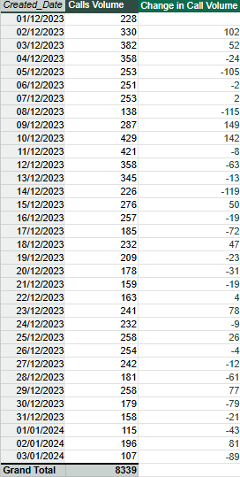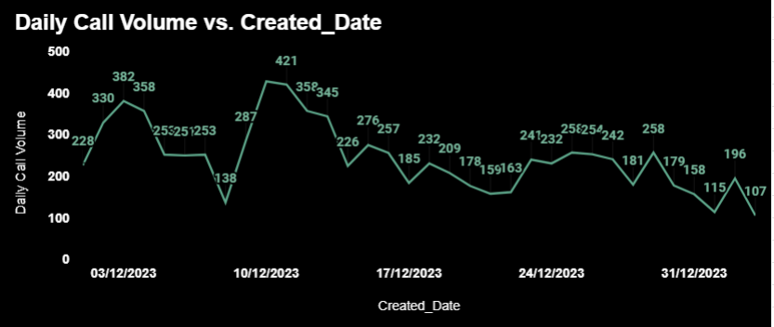

5)Which months experienced the highest and lowest call volumes?

There are only 34 days given, which is for only two months, December and January. 31 days of December and only 3 days of January.
On 10/12/23, there was the highest call volume, i.e, 429.
Formula used: =Max(call volume column)
On 03/01/2024, there was the lowest call volume, i.e., 107.
Formula used : =Min(call volume column)
December – Highest call volume.
January – Lowest call volume.
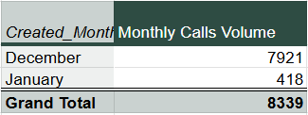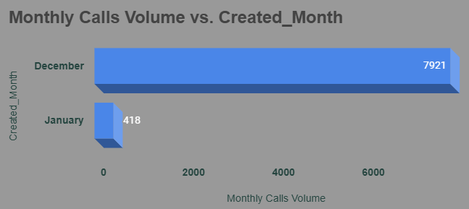

6)What is the total operational cost for that month?
The operational cost for that month = Total net income of the month - Astrologer's income of the month
1) December –
Astrologer earning = 93666.16
Function used: =SUMIF(data!R:R,"December",data!AC:AC)
Net Earnings = 201974.6253
Function used:=SUMIF(data!R:R,"December",data!AD:AD)
Operation cost =201974.62 - 93666.16
December Operation cost = 108308.46
2) January –
Astrologer earning = 5360.40
Function used: =SUMIF(data!R:R,"January",data!AC:AC)
Net Earnings = 11772.69
Function used: =SUMIF(data!R:R,"January",data!AD:AD)
Operation cost =11772.69 – 5360.40
January Operation cost = 6412.29
7)What is the average number of calls handled per agent per day?
Total Calls: 8435
Function Used: =COUNTIF(data!H:H,data!$H$9)
Number of days: 34
Function Used: =COUNT(UNIQUE(data!P:P))
Number of agents(Guru)- 150
Function used: =COUNTA(UNIQUE(data!A1:A27950))

First, we have to find the average number of calls per day.
Average number of calls per day = Total calls / Number of days
= 8435 / 34
= 248.09
Now find the average number of calls handled per agent per day.
Average number of calls handled by per agent per day = Average number of calls per day / Number of agents
= 248.09 / 150
= 1.65
So we can say that approx. 2 calls are handled per person per day.

8)How many repeat callers are there, and what percentage of total calls do they represent?
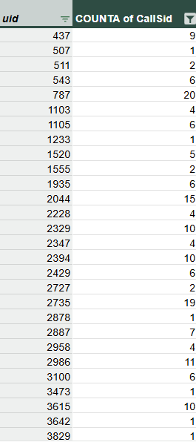
With the help of this pivot table, we can find the total number of callers.
Total number of callers = 3628
Formula used:=COUNT()
Now we have to find the repeater callers. The callers who use the call service more than once,
For that, we can apply the filter on the pivot table in the user ID section, which will show the callers who called more than once.
Repeater callers = 1273
Formula used: =COUNT()
Single time callers (Non repeaters) = Total callers – Repeater callers
Non-Repeater callers = 2355
PERCENTAGE OF TOTAL CALLS –
Total number of calls = 8339 ( count of calls )
The caller placed 5984 repeated calls.
Repeated calls = 5984 – 1st call placed by callers
= 5984 – 1273 (count of repeated callers )
Repeated calls = 4711
Percentage of repeated calls = (Repeated calls *100)/Total calls
= (4711*100/8339)
Percentage of repeated calls = 56.49%

9)What are the total sales generated by the call centre for each product category?
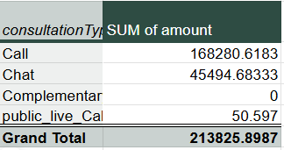
Consultation Type is considered a Product category. We can say that the call is the highest category compared to the others.

10)How many calls were made for each user ID and guru ID?
The list is very long, as 3629 users used the call service, and they made 8435 calls in total.
Formula used: =COUNTIF(data!H:H,"Call")(To measure total calls )
=COUNT()(To measure users)
With the help of a pivot table, we can see the calls made for each User ID and Guru Name.
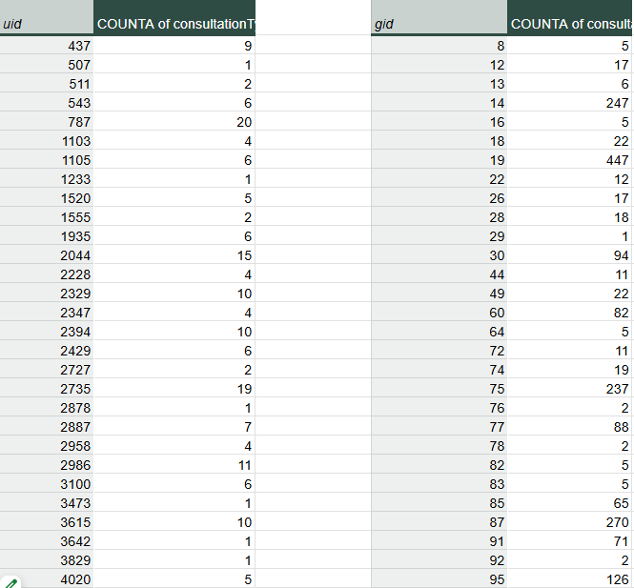

11)What is the correlation between call duration and customer satisfaction?
The correlation between call duration and customer satisfaction is 0.000037
Formula used : =CORREL(data!$AF$2:$AF$27951,data!$AG$2:$AG$27951)
There is almost no linear relationship between how long a call lasts and how satisfied the customer is.

12) Which guru has the highest and lowest customer satisfaction scores?
If we take the average of all gurus' ratings, then Tarot Rittika(Guru id – 80) got the lowest satisfaction score, but she only consulted once, and only one user rated her. While Tarot Mystical(Guru id – 305) got the highest average rating but she consulted only two users with the chat service.
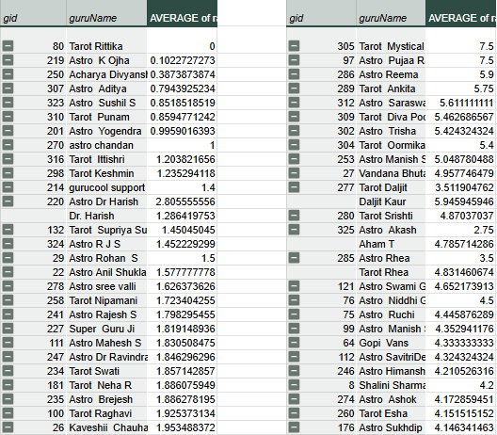

13) What is the average customer satisfaction score by month?
There are only two months given in the data, i.e., December 2023 and January 2024.
December - 2.94 January - 2.67
Formula used –
=AVERAGEIF(data!R2:R27951,"December",data!AG2:AG27951)
=AVERAGEIF(data!R2:R27951,"January",data!AG2:AG27951)

14) How many categorical columns are there in the data? [Search about categorical and continuous data, and try to answer this question]
Categorical Columns (Qualitative):
- chatStatus
- guru
- guruName
- gid
- uid
- consultationType
- website
- refundStatus
- isWhiteListUser
- freeCall
- freeChat
- callChannel
- callIvrType
- callStatus
- region
- userCallStatus
- created_month (extracted)
- created_year (extracted)
- created_time (optional, if binned or grouped)
Total Categorical Columns = 18

Continuous Columns (Quantitative):
- chatSeconds
- userOnCallDuration
- astrologerOnCallDuration
- astrologersEarnings
- amount
- netAmount
- rating
Total Continuous Columns = 7

Subjective Questions

1. Should the investment be used to hire more agents, improve training programs, or upgrade call center technology?

1) Hiring More Agents
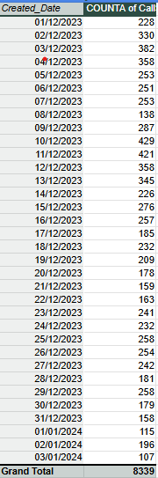
Average number of calls per day = 250 (Formula : =AVERAGE())
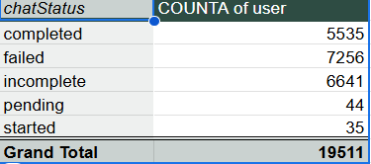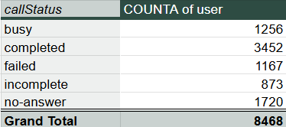
% of calls gets complete = 40.77 % {Formula= (Completed calls * 100)/ total calls}
The call centre receives approximately 250 calls per day, but only 40.77% of calls are completed. To manage the workload, investment is needed in hiring agents.

2) Improve training programs
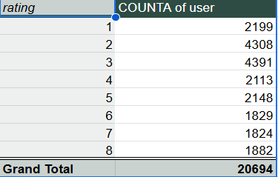
Only 37.13% of users are satisfied with the service.
Total users = 20694
Satisfied user (Rating-5,6,7,8) = 37.13 %
(formula- =(SUM(satisfied users)*100/total users))
Unsatisfied user (Rating-1,2,3,4) = 62.87 %
I think the investment should be used to improve the training program.

3) Upgrade call center technology
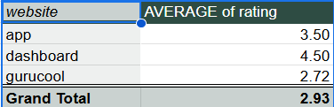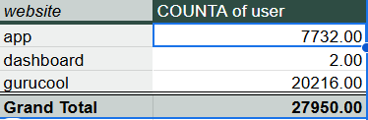
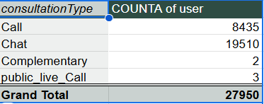
69.8% of users use the chat service, primarily through the Gurucool platform, which has an average rating of just 2.72, indicating significant user dissatisfaction. This highlights a clear need for technology upgrades to improve service quality, user experience, and retention. Investing in tech will enhance system performance and satisfaction, though potential risks like implementation delays and training requirements should be planned for and mitigated.

2)What are the potential risks of each investment option (hiring, training, technology upgrades), and how can they be mitigated?
Name the chart/spreadsheet function you will use for solving the problem.
1) HIRING
Possible Problems (Risks):
- High hiring cost – The company has to spend money on hiring, like paying agencies or job platforms.
- Training cost wasted – If the new employee doesn’t perform well, the time and money spent on training them goes to waste.
- Leaves quickly – If the person doesn’t stay long, it wastes company time and effort.
- Wrong skills – If the person hired doesn’t have the right skills, it may lead to poor work or delays.
- Bad behavior – If the new hire behaves badly or unprofessionally, it can affect the company’s image.
Mitigating These Problems (Solutions):
- Take more interview rounds to better check their skills and behavior.
- Clearly explain the job role and expectations before hiring.
- Check if they match the company culture to make sure they’ll stay longer.

2) TRAINING
Only 37.13% of users are satisfied with the service.
Total users = 20694
Satisfied user (Rating-5,6,7,8) = 37.13 %
(formula- =(SUM(satisfied users)*100/total users))
Unsatisfied user (Rating-1,2,3,4) = 62.87 %
Possible Problems (Risks):
- High cost – Hiring outside trainers or giving paid certifications can be expensive.
- Employees may leave – After learning new skills, some employees may switch jobs for better offers.
- Training may not help – If the training is not related to the actual work, it won’t improve performance.
Mitigating These Problems (Solutions):
- Use in-house training where possible, and check if the cost is worth the results.
- Build a positive work environment and give chances to grow within the company.
- Use contracts or agreements so employees stay for some time after training.

3) TECHNOLOGY UPGRADES:
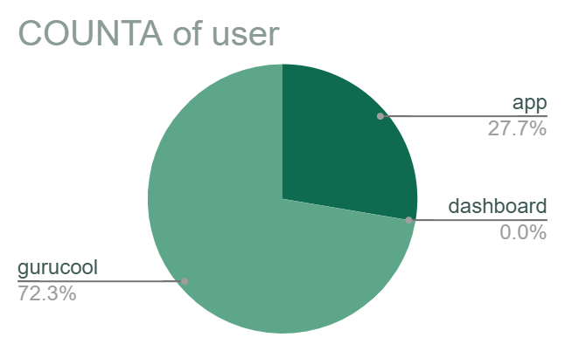
69.8% of users use the chat service, primarily through the Gurucool platform, which has an average rating of just 2.72, indicating significant user dissatisfaction. This highlights a clear need for technology upgrades to improve service quality, user experience, and retention. Investing in tech will enhance system performance and satisfaction, though potential risks like implementation delays and training requirements should be planned for and mitigated.
Possible Problems (Risks):
- High cost – Upgrading systems can be expensive. It includes buying software, licenses, hardware, and training.
- Need for training – Employees may need help learning how to use the new systems.
- May not work as expected – The new tools might not perform well or might need more resources (like faster internet or better devices).
- Risk of losing data – Data might get lost or corrupted during the upgrade.
How to Reduce These Problems (Solutions):
- Make a clear budget plan before starting the upgrade to avoid overspending.
- Train employees properly so they can use the new tools with confidence.
- Back up all important data before making any changes, so nothing is lost.

3)How does AstroSage's call center performance compare to AstroGuru's average call volume, customer satisfaction, and agent performance?
Will you use any aggregation function or a visualization here to solve the problem?
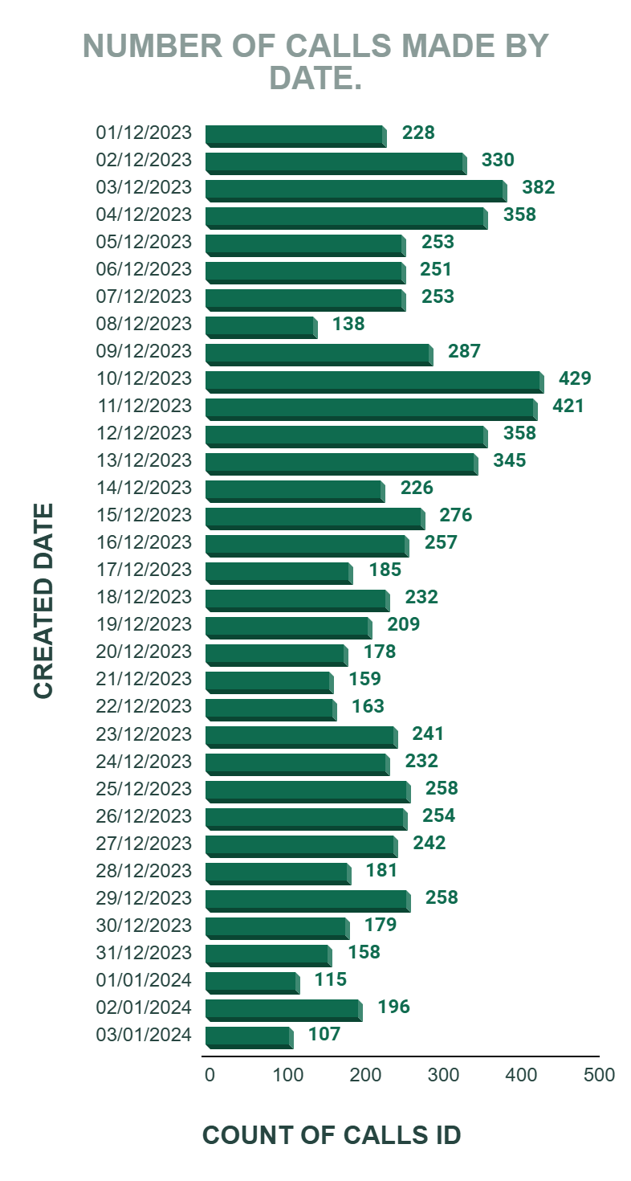
The call center receives around 250 calls per day, and there are 151 gurus available to handle them.
However, out of 8,339 total calls, only 3,452 were completed, which is just 40.77%.
This means 59.23% of users didn’t get their call session, even after booking it.
This low completion rate is one of the main reasons why the average rating for the call service is only 3.5.
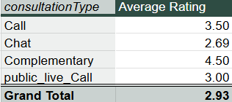
If astrologers’ ratings improve, the overall company rating will also improve.
Since 78.69% of the company's net income and 78.44% of astrologers’ earnings come from the Call service, it's clearly the key revenue source.
So, investing in training programs to improve astrologer performance would be a smart and strategic move to maintain and grow this success.
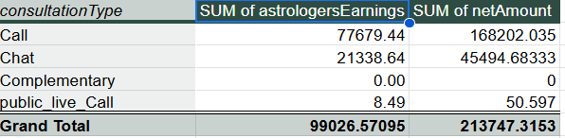
Percent of call income = (Call income * 100)/Total income
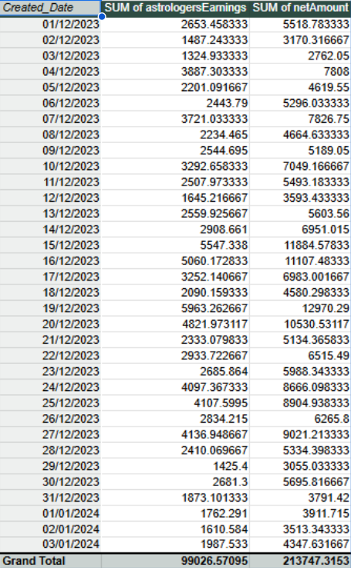

The performance of agents (astrologers) is crucial to the company’s success because their earnings are strongly linked to the company’s income.
Using the formula “=CORREL()”, the correlation between astrologers’ earnings and the company’s net income is 0.9969, which shows a very strong positive relationship.
This means:
When agent earnings increase, the company’s net income also increases-almost every time and in a predictable way.
A correlation of 0.99 indicates that both are highly interconnected, and improving agent performance can directly boost company profitability.

4)How can the call center improve its handling of peak call periods to ensure high customer satisfaction?
Mention the functionality you will use for giving the suggestions, will it be any aggregated function or a visualization?

Dates 2023-12-10 and 2023-12-11 received the highest calls.
On December 10 and 11, 2023, the call center received the highest number of calls.
However, only 34.82% of users were successfully served, while the remaining 65.18% received messages such as "astrologer busy" or had their calls cancelled due to the unavailability of astrologers.
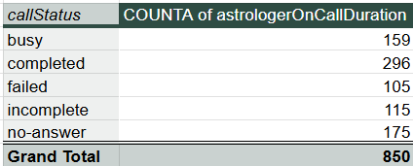
Completed call % = (Completed calls * 100)/ total calls
Analysis of peak hours -
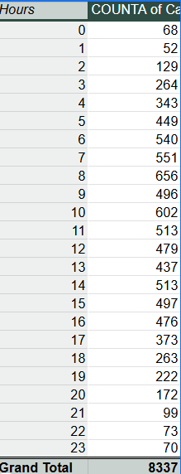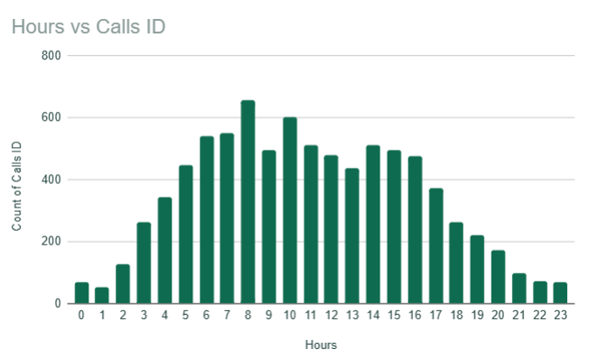
Here we can see the hourly distribution of calls. First, we have to take out hours from creation time with the help of = HOUR FUNCTION, later by taking hours in a row, the count of calls in values, and consultation type in filters, and set that filter as call. This is how we can form the pivot table, and later with the help of the pivot table, we can visualize it witha chart.
- Introduce Live Streaming:
The company can offer live sessions where astrologers interact with multiple users at once. This will reduce waiting time, keep users engaged, and also help generate more revenue.

- Optimize Agent Shifts:
Schedule more agents during peak hours (like evenings or weekends) to handle higher call volumes efficiently.
- Hire Part-time or Freelance Agents:
Keep a few on-call or freelance astrologers who can step in during busy times.
This helps manage the load without adding permanent staffing costs.

5) Based on historical data, what strategic initiatives should be prioritized to improve efficiency and customer satisfaction?

STRATEGY 1- Training programs
Only 37.13% of users are satisfied with the service.
Total users = 20694
Satisfied user (Rating-5,6,7,8) = 37.13 %
(formula- =(SUM(satisfied users)*100/total users))
Unsatisfied user (Rating-1,2,3,4) = 62.87 %
Agent Training & Quality Improvement
- Strong correlation (0.9969) between agent earnings and company profit shows that agent performance directly impacts business.
- Conduct regular training to boost astrologer skills, which in turn improves user ratings and retention.
STRATEGY 2 – Upgrade Technology.
Upgrade Technology
- With 69.62% of users using the chat service and an average rating of only 2.72 (for Gurucool), there is a clear need to enhance the chat platform for a smoother user experience.
STRATEGY 3 – Optimize Staffing During Peak Hours
- On peak days like 2023-12-10 & 2023-12-11, only 34.82% of users got service.
- Use shift planning, part-time astrologers, or live sessions to better handle high traffic.
This move can make the company stand separate among the rivals. And bring customers and revenue to the company.

6)What can be the key factors contributing to high customer satisfaction scores, and how can these be leveraged to improve overall performance?
What is the basis for the suggestions? And mention how you decided if the satisfaction score affects the ratings.

69.80% of total users use the chat service.
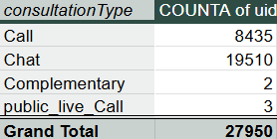
% of user using chat = (Chat user*100)/ Total user
Rating of 6,7,8 is considered as the high satisfaction range.
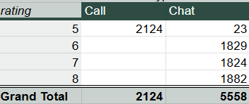
Only chat service receives the rating of 6,7,8.
As 69.80% of total users use the chat service and 100% of high satisfaction scores is given by chat user only, then the Chat service can be considered as the key factor contributing to high satisfaction score.
Improvements:
To further enhance user experience, the company can:
- Introduce AI chatbots to handle basic queries and reduce wait times.
- Train employees to adopt new tools, technologies, and workflows that support better service delivery.
These steps will help the company boost overall performance and user satisfaction.

7) How should the call center balance the workload among agents to ensure optimal performance and avoid burnout?
Mention your approach and spreadsheet function for the answer.

Total call receive = 8339
Average number of calls per day = 250 (Formula : =AVERAGE())
% of calls gets complete = 40.77 % {Formula= (Completed calls * 100)/ total calls}
Call centre receives approx. 250 calls per day, but only 40.77% of calls are completed in total from the astrologer's side.

Suggestions-
1) To balance the workload company can analyze the historical data. The hourly distribution of calls can help the company to balance workload accordingly among agents.
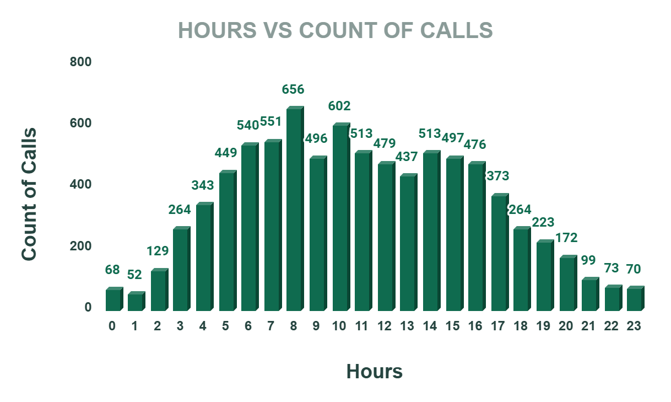
2) Introduce live streaming to handle multiple users at once and increase engagement.
3) Optimize agent shifts by scheduling more agents during peak hours.
4) Use part-time or freelance astrologers to manage high workloads cost-effectively.
5) Implement AI chatbots to handle basic queries and reduce agent load.
6) Analyze hourly call trends to distribute workload more evenly among agents.

8)What new technologies or tools could be implemented to enhance call center operations and customer service?
- AI Chatbots
Handle basic user queries 24/7, reduce agent workload, and improve response speed.
- Live Streaming Sessions
Allow astrologers to interact with multiple users at once, especially during peak times.
- Call Routing Systems
Automatically direct users to the best available astrologer, reducing wait and call drop rates.
- Real-time Dashboards & Alerts
Monitor agent performance, call traffic, and satisfaction in real time for quick decision-making.
- Automated Feedback Collection Tools
Collect post-session ratings and suggestions without manual effort.

9)What metrics should be included in the final dashboard to comprehensively view call center performance and guide investment decisions?

DASHBOARD
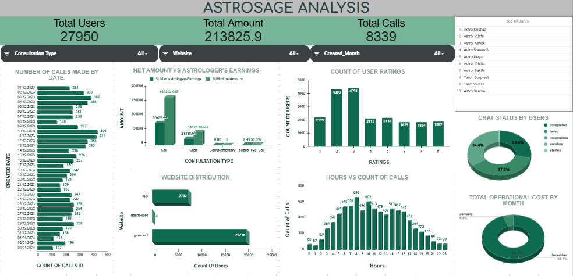

Metrics that are included in Dashboard-
1) KPI (Key performance indicator) –
- Total Users: 27950 – Represents the total number of users.
- Total Amount: 213825.9 – Sum of total revenue
- Total Calls: 8339 – Total count of calls made.
2) Number of Calls by Date
- Shows daily call volume trend – useful to detect peak/low activity days.
3) Net Amount vs Astrologer’s Earnings
- Compares how much astrologers earned vs what the company made (net).
4) Count of User Ratings
- Shows how satisfied users were based on rating distribution.
5) Call Distribution by Website
- Identifies which platform is generating the most of the calls.
6) Calls Distribution by Hours
- Summarizes the number of calls made in hours.
7) Total Operational Cost by Month
- Breaks down operational costs per month; January vs December.
8) Chat Status by Users
- Shows the distribution of chat statuses (completed, failed, etc.)
9) Top 10 Gurus
- Shows the top 10 gurus who are performing well in the organization with an 8 rating.
10) Slicers Used
These are dropdown filters added for interactivity:
- Created_Month
- Website
- Consultation Type
These allow users to dynamically explore the data for specific periods, channels, or service types.

10) How would you allocate a 1 crore rupee investment to optimize operational efficiency, enhance customer satisfaction, and boost profitability, and what analysis-based recommendations would you offer to support this?
[you have to give bullet pointers to answer this question]

1. Technology Upgrade – ₹40 lakhs (40%)
- 69.62% of users use chat services, mainly on Gurucool, which has a low average rating of 2.72.
- Recommendation:
Upgrade the chat platform (UI/UX).
Introduce AI chatbots for instant query resolution.
Improve backend performance to reduce lag or crashes.
- Expected Outcome: Improved chat satisfaction, better retention, and reduced operational delays.

2. Agent Training Program – ₹25 lakhs (25%)
- Only 40.77% of booked calls are completed. Calls are the main revenue driver, contributing 78.69% of the company’s income.
- Recommendation:
  - Conduct monthly training on soft skills, upselling, and technical handling.
  - Use analytics to identify underperforming agents and offer targeted coaching.
- Expected Outcome: Increase in successful calls, better customer experience, and improved satisfaction.

3. Support Infrastructure, Data Security & Customer Care Tools – ₹35 Lakhs (35%)

Hire freelance/part-time agents to manage peak hours and reduce customer wait time.
- Invest in infrastructure and data protection (cloud backups, system stability).
- Set up automated feedback tools (post-call surveys, follow-ups) to improve customer support and satisfaction.

THANK YOU

